

Name: Karan Kumar Pal
PRN: 25070122098
Branch: CSE (25-29)
Semester: 3
TITLE: : Implement a Java program to demonstrate inheritance and interfaces using suitable real-world examples.
ASSIGNMENT No.: 7
Subject: Programming with Java

Problem Statement:

Implement a Java program to demonstrate inheritance and interfaces using suitable real-world examples.

Learning Objectives:

To implement inheritance and interfaces for achieving code reusability and abstraction.

Theory:

Inheritance allows one class to acquire the properties and methods of another class, promoting code reuse and reducing redundancy. Java supports single inheritance through the extends keyword. Interfaces define a contract that implementing classes must follow, enabling abstraction and multiple inheritance of type. Together, inheritance and interfaces support polymorphism and modular software development. They are fundamental concepts of object-oriented programming.

Outcomes:
Successfully implemented inheritance and interfaces in Java to achieve code reusability and abstraction. Applied these concepts to build real-world applications like a Shape calculator and an E-Commerce Product System.
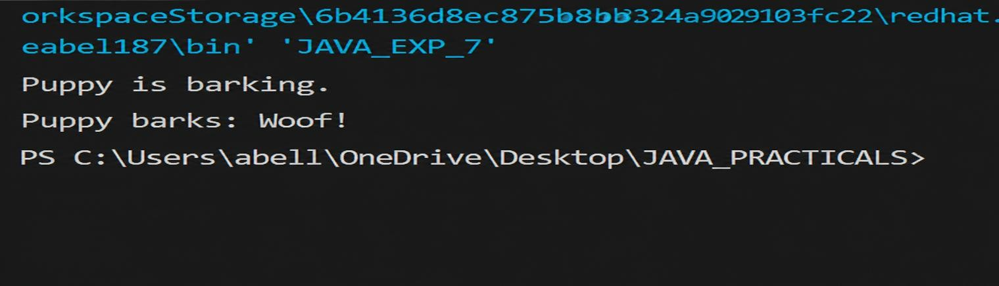
interface Sound{ void makeSound();
}

class Animal{
String name; Animal (String n){
this.name = n;
}
void eat(){
System.out.println(name + " is barking.");
}
}

class Dog extends Animal implements Sound{ Dog(String n){
super(n);
}
public void makeSound(){ System.out.println(name + " barks: Woof!");
}
}

public class JAVA_EXP_7{

public static void main(String[] args) { Dog dog = new Dog("Puppy"); dog.eat();
dog.makeSound();
}
}

Conclusion:

This assignment demonstrates how inheritance enables code reuse by allowing subclasses to acquire properties and methods from a parent class, while interfaces define contracts that ensure consistent behaviour across different classes. The Shape application and E-Commerce Product System successfully illustrate how these OOP concepts support abstraction, polymorphism, and modular software design in real-world scenarios.

Exercise:

- Create a Shape application where Circle and Rectangle inherit from Shape and calculate area.

class Shape {
void area() {
System.out.println("Area method not defined for generic shape.");
}
}

class Circle extends Shape { double radius; Circle(double radius) {
this.radius = radius;
}
void area() {
double result = Math.PI * radius * radius; System.out.println("Circle Area: " + result);
}
}

class Rectangle extends Shape { double length, width;
Rectangle(double length, double width) { this.length = length;
this.width = width;
}
void area() {
double result = length * width; System.out.println("Rectangle Area: " + result);
}
}

public class JAVA_EXP_7 {
public static void main(String[] args) {

Shape circle = new Circle(5);
Shape rectangle = new Rectangle(4, 6);

circle.area(); rectangle.area();
}
}
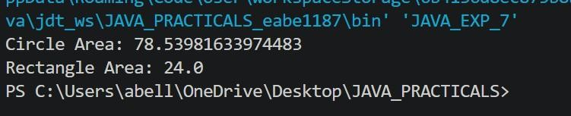

- Develop a E-Commerce Product System where electronic, clothing, and grocery products inherit common properties and implement product interfaces.

interface ProductInfo { void displayDetails();
}

class Product { String name; double price;
Product(String name, double price) { this.name = name;
this.price = price;
}
}

class Electronics extends Product implements ProductInfo { int warrantyYears;
Electronics(String name, double price, int warrantyYears) { super(name, price);
this.warrantyYears = warrantyYears;
}
public void displayDetails() {
System.out.println("Electronics -> " + name + " | Price: " + price + " | Warranty: " + warrantyYears + " yrs");
}
}

class Clothing extends Product implements ProductInfo { String size;
Clothing(String name, double price, String size) { super(name, price);
this.size = size;

}
public void displayDetails() {
System.out.println("Clothing -> " + name + " | Price: " + price + " | Size: " + size);
}
}

class Grocery extends Product implements ProductInfo { String expiryDate;
Grocery(String name, double price, String expiryDate) { super(name, price);
this.expiryDate = expiryDate;
}
public void displayDetails() {
System.out.println("Grocery -> " + name + " | Price: " + price + " | Expiry: " + expiryDate);
}
}

public class JAVA_EXP_7 {
public static void main(String[] args) {
ProductInfo item1 = new Electronics("Laptop", 50000, 1); ProductInfo item2 = new Clothing("T-Shirt", 500, "M"); ProductInfo item3 = new Grocery("Pulse Packet", 600, "Nov-2027");

item1.displayDetails(); item2.displayDetails(); item3.displayDetails();
}
}
